**SPRING REST using SPRING BOOT 3  
JWT Handson**

Create authentication service that returns JWT

->Step-1: Creating Spring Boot Project

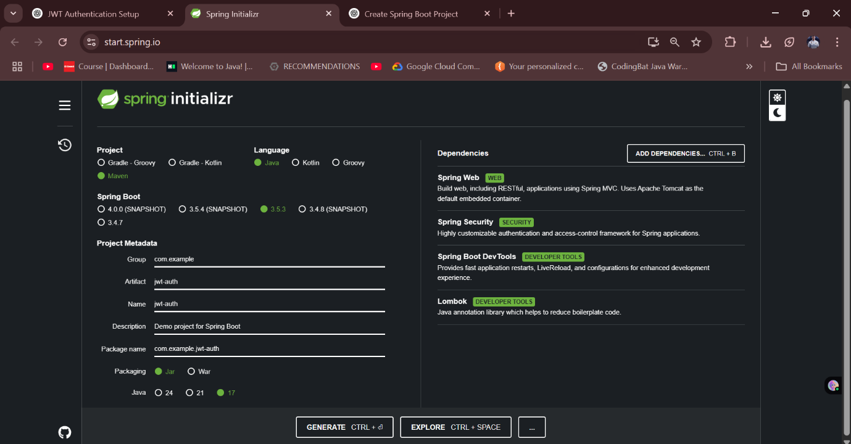

Step-2: Adding JWT Dependency to pom.xml and running it

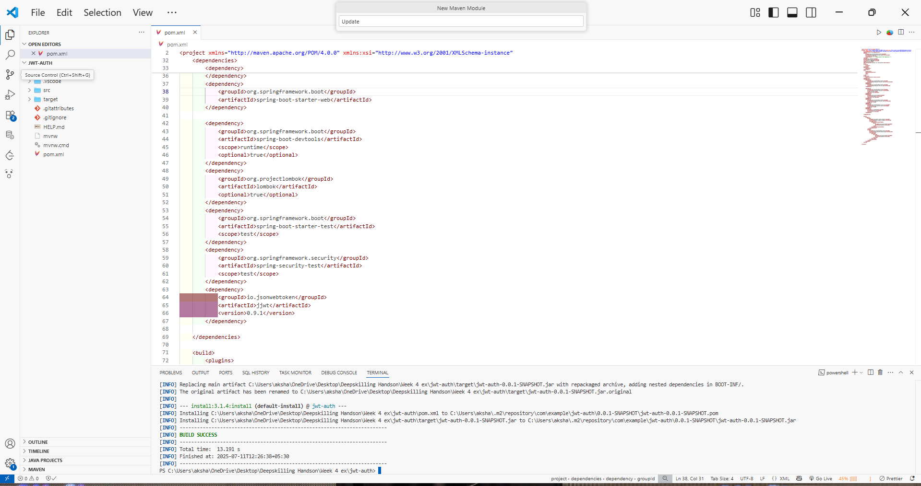

Step-3:File Structure Overview

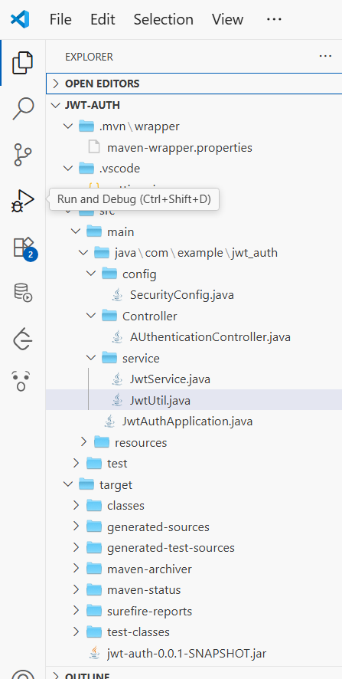

Step-4: Creating AuthenticationController.java

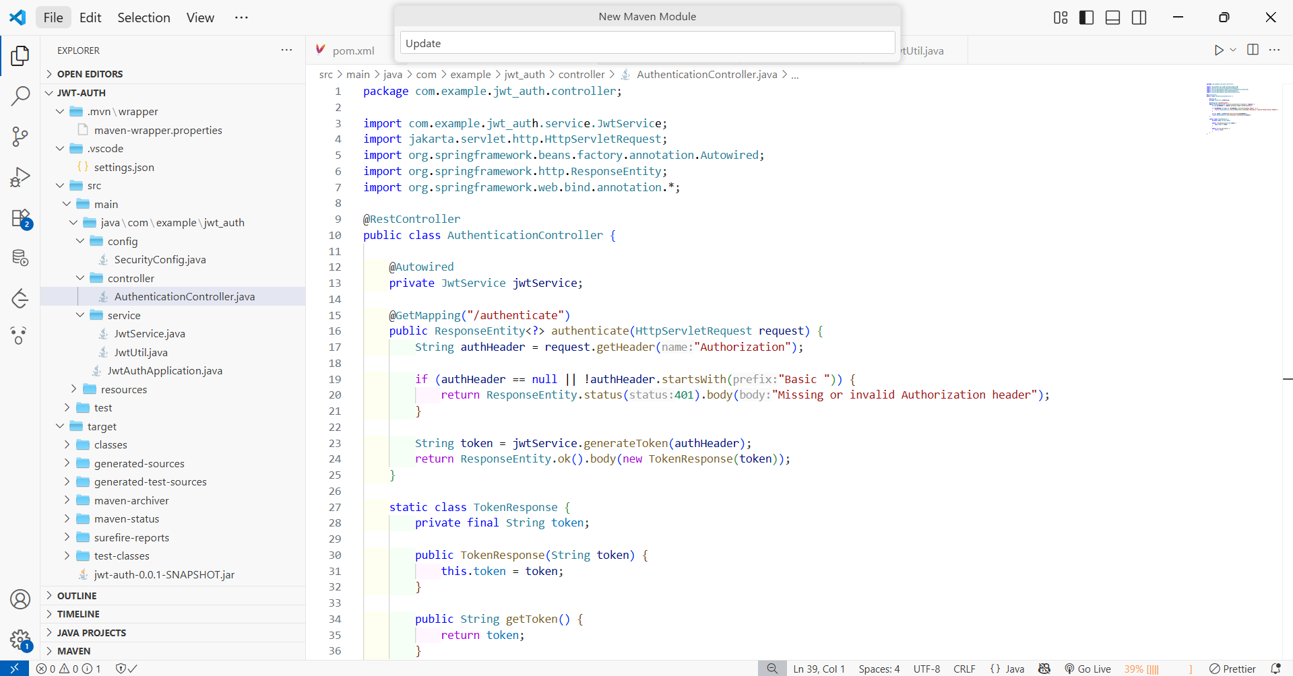

Step 5: Creating JwtService.java

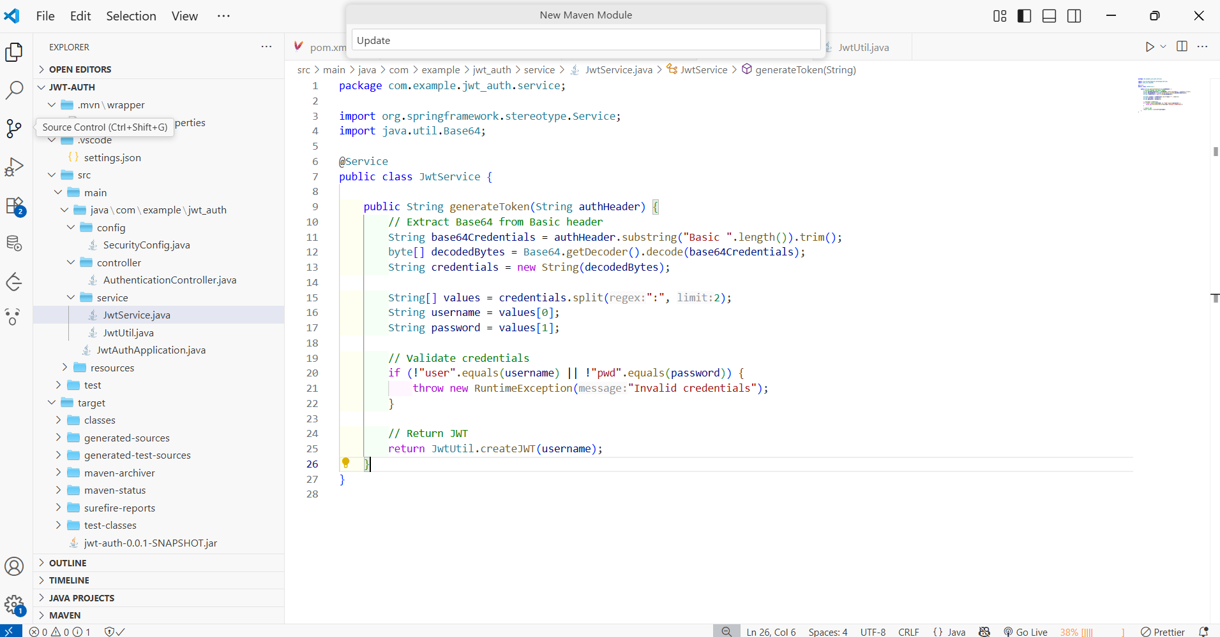

Step-6: Creating JwtUtil.java

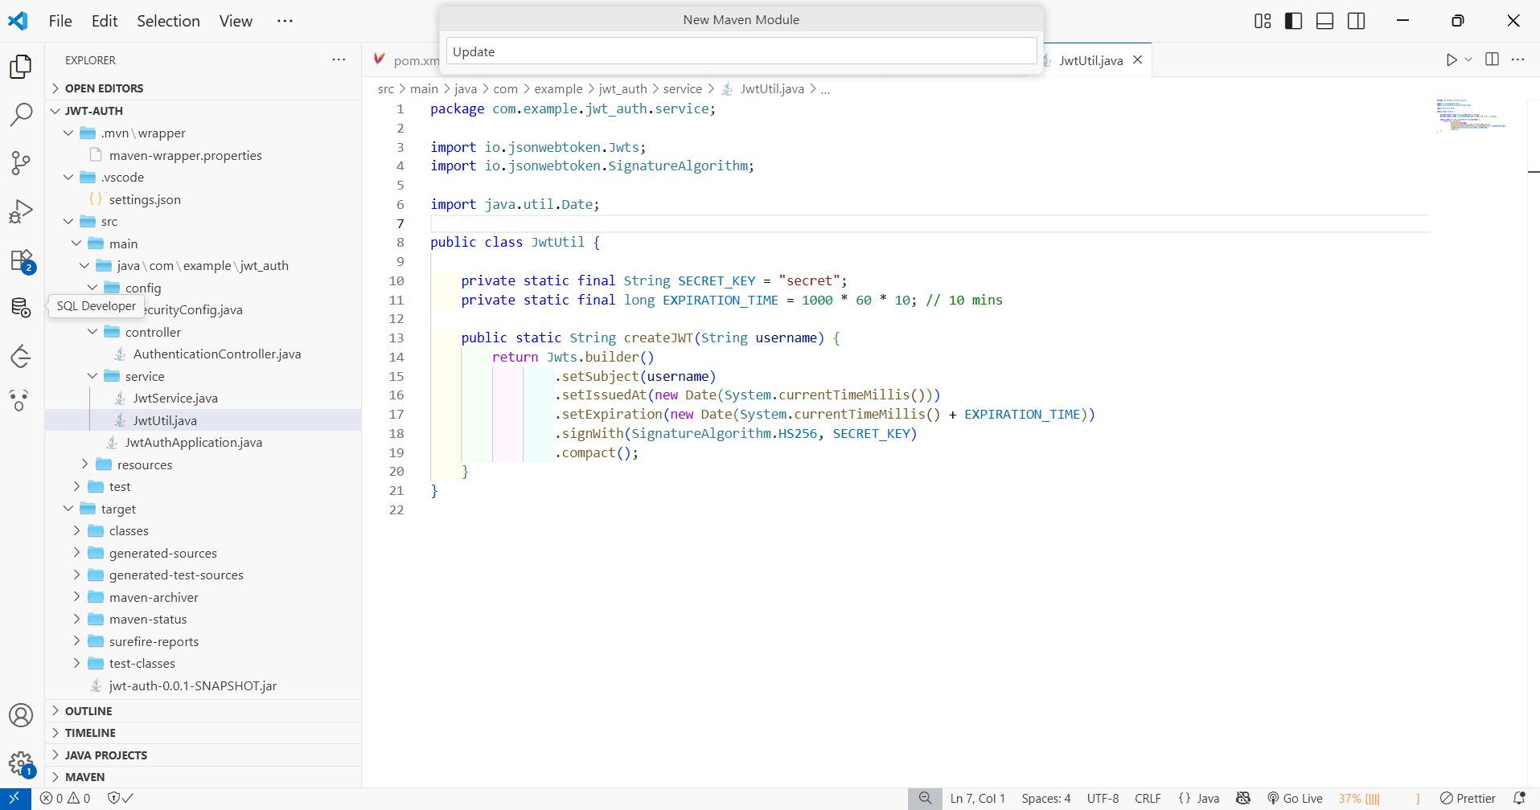

Step-7: Creating SecurityConfig.java

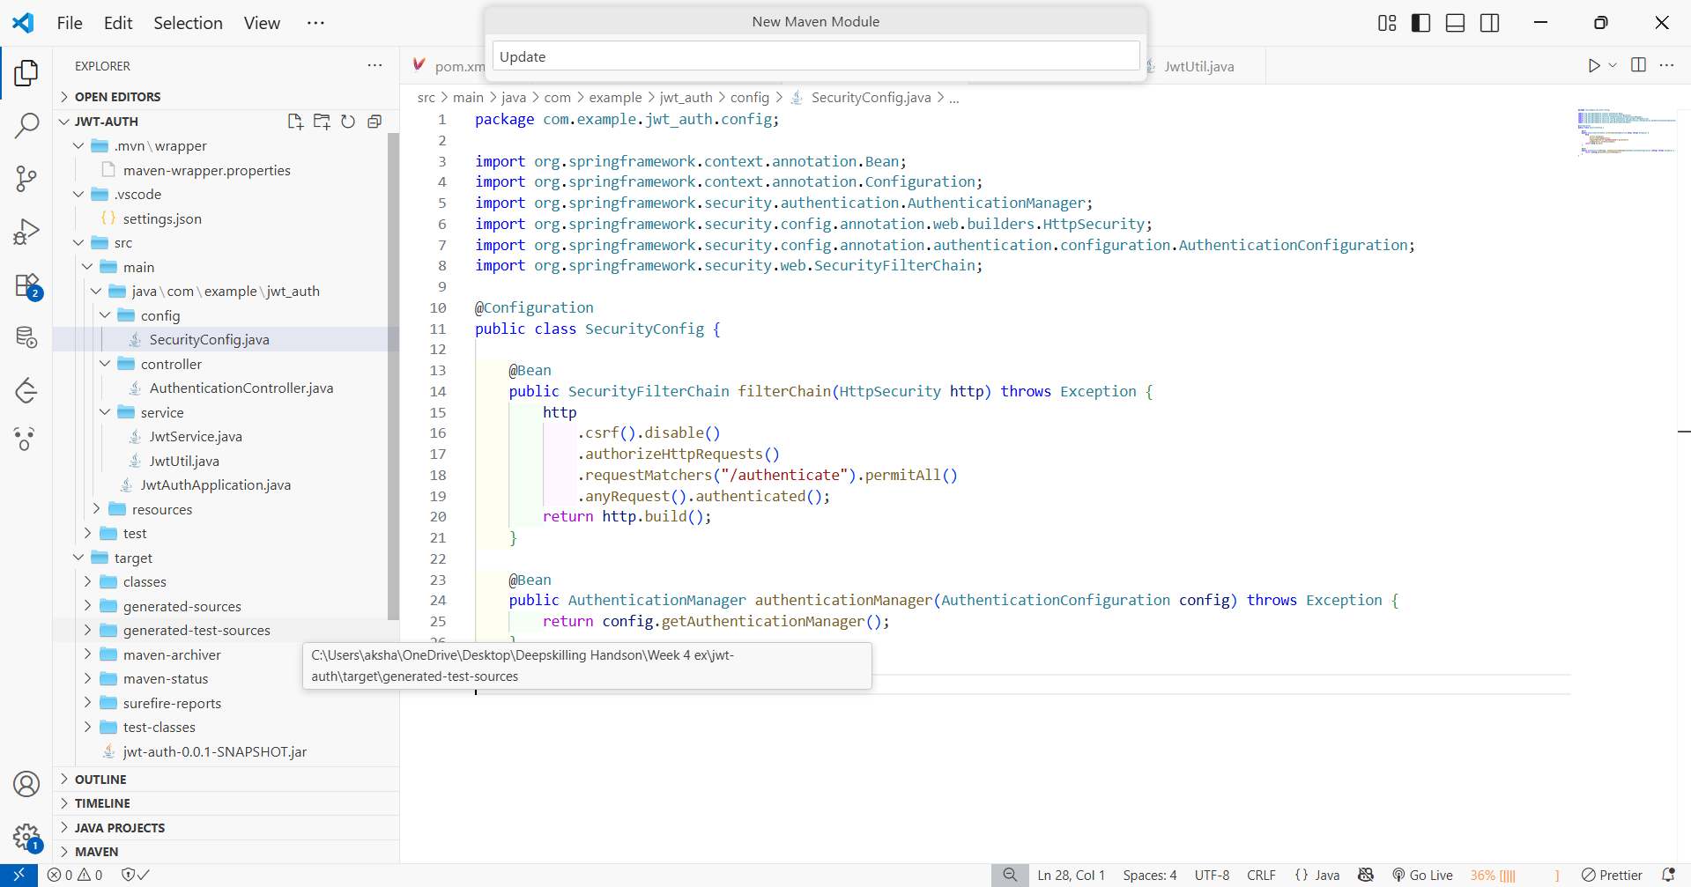

Step-8:Running and Testing

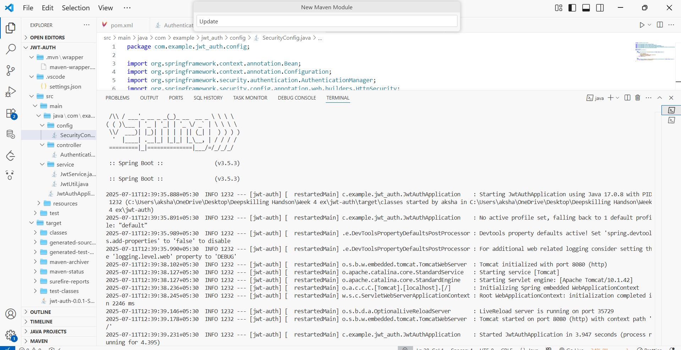

Output->

